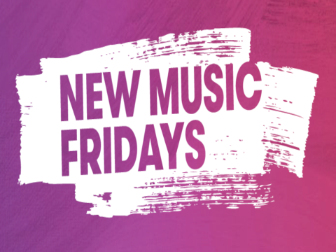
@Friday4newmusic #newmusicfridays

Nyilatkozatok a nemzetközi megjelenési napról
- idézetek angol nyelven -

Kim Bayley, chief executive, Entertainment Retailers Association:
“Retailers and digital services are the ultimate link in the chain between artists and music fans. Having a single worldwide release day reduces customer confusion about when new music is available and focuses everyone's attention on new releases. Retailers are working hard to implement the change to Fridays and ensure that the advent of New Music Friday is a success.”

James Donio, president, Music Business Association (Music Biz)
“The Music Business Association (Music Biz) is committed to working with our members and industry partners in the United States to make a smooth and successful transition to New Music Fridays.”

Frances Moore, Chief Executive of IFPI
“The switch to New Music Fridays is about getting new music to fans at the time they most want to enjoy it, whether that be in physical stores or online. It’s also an opportunity to recreate excitement around the release of music – the message is “Think Friday, Think New Music. The global release day also helps artists, labels and retailers by limiting the time between releases in different countries and thus narrowing the gap on piracy. The move made today has been a great example of cross-sector cooperation, involving labels, artists, retailers and others across more than 45 markets.”

Paul Pacifico, chief executive, Featured Artists Coalition (FAC)
“The FAC welcomes any initiative that brings artists and fans closer together and the Global Release Day does just that, making sure that all fans, wherever they are in the world, can get legal access to new tracks as soon as they are released. Making Global Release Day Friday brings the additional excitement of launching major new releases in the run-up to the weekend.”

John Smith, president, International Federation of Musicians (FIM)
“FIM fully supports the move to New Music Fridays. Our industry, our membership and our audiences are increasingly global, and a move to a global release Friday offers an exciting opportunity to release music at a time when people most want to listen to and buy it.”

